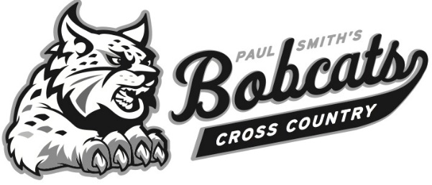

2017 Cross Country Team ~
Castleton University Invitational
Updated: 2 September 2017

Name | Year | 1 Mi | Finish | Place Pts | Km Pace | Mile Pace
Women’s Roster
Kelly Bosloper | FR |  | 24:21 | 20 | 4:52 | 7:50
Tessa White | JR |  | 25:44 | 30 | 5:08 | 8:17
Name | Year | 1 Mi | Finish | Place/Pts | Km Pace | Mile Pace
Joseph St. Cyr | SR | 5:36 | 28:12 | 3/3 | 3:31 | 5:41
Jakob Koiva | FR | 6:45 | 33:19 | 35/28 | 4:09 | 6:43
Matt Frye | FR | 6:41 | 33:52 | 37/30 | 4:14 | 6:49
Isaac Leach | SO | 6:40 | 33:33 | 36/29 | 4:12 | 6:45
Kyle Ruddy | FR | 6:48 | 35:43 | 42/35 | 4:28 | 7:11
Tim Ellis | FR | 6:40 | 35:32 | 41/34 | 4:27 | 7:09
Thomas Firkins | SO | 6:38 | 35:46 | 43 | 4:28 | 7:12

Winners (Men) Winners (Women)
- Union (51) 1. Albany College (45)
- Mass. Liberal Art (73) 2. Castleton University (67)
- Castleton University (75) 3. Union (78)
- Southern Vermont (103) 4. Green Mountain (90)
- SUNY Canton (115) 5. St. Joseph (136)
- Paul Smith’s (121) 5. SUNY Canton (136)
- Green Mountain (166) 7. Southern Vermont (142)
- New England College (219) 8. Mass. Liberal Art (186)
Albany College Inc. New England College Inc.
SUNY Adirondack Inc. SUNY Adirondack Inc.
Paul Smith’s Inc.
PSC Athletic Website: http://paulsmithsbobcats.com/landing/index
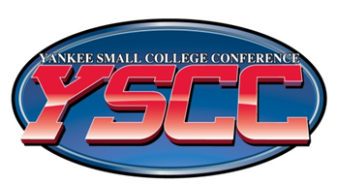
Coach: Jim Tucker
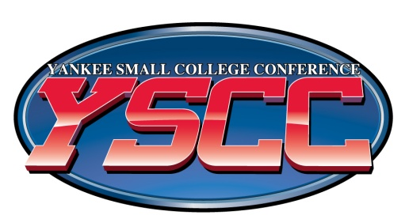
Assistant Coach: Philip Dybfest-Muha

